2 Way 19" SoHo Horizontal Mounted Surge Protected PDU - UK Sockets (PDU-2WS-H-SP-SOHO)

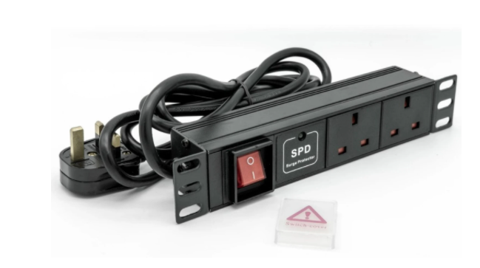

Description:

The LMS Power PDU-2WS-H-SP-SOHO is a high-quality 10-inch Rackmount PDU (Power Distribution Unit) that simply fits within the compact, 10-inch SoHo (Small Office Home Office) range of wall cabinets.
Complete with surge protection to help smooth our electrical spikes to Ethernet Switches, VoIP gateways and DVRs, its a must-have accessory for 10-Inch cabinets
Robust, alloy design complete with rackmount brackets fitted, high-quality Neon Switch and of course UK output sockets together with a high quality, BSI-fitted
13 Amp UK plug.

Key Features:
Standard UK 3-Pin power outlets for your appliances
1U high means, 10" Wide for the small 10" SoHo cabinet
Neon On/Off Rocker switch to prevent accidental turn off
Backed up by LMS Power's exclusive 3-year warranty

Applications:
Create instant power feeds to your data, telecom or server cabinets
Provide effective power for cabinet cooling fans, UPS systems
Ideal as stand-alone trailing sockets outside the cabinet

Product Code:
Part Number: PDU-2WS-H-SP-SOHO
EAN: 8400800035899
Weight: 0.5Kg approx

Technical Specifications:
Warranty LMS Data 3-Year Warranty
Chassis 1U 10-inch with mounting brackets
Output Sockets 2 UK 3-PIN Sockets
Power Input Fitted UK 3PIN BSI Plug 13 Amp
Flex Length 2.5 metres (approx)
Power Control On/Off Rocker Switch (illuminated)

Supplied With:
PDU-2WS-H-SP-SOHO 2 Way Horizontal PDU
10-inch cabinet brackets (Fitted)
* Specifications and product design are subject to change. E&OE.

Looking for a costeffective and electrically surged-protected 10-inch wide PDU for SoHo Wall Cabinets or other 10-inch wide frames or enclosures? Introducing the new PDU-2WS-SP-SOHO surge protected PDUs which a must-have accessory the the LMS Data range of 10-inch SoHo wall enclosures, offering effective and of course ‘clean’ power to your installed LAN switches, PBX or other electrical sensitive devised. Durable in design, featuring standard, dual UK Power sockets with integral, illuminated rocker on/off switch together with surge protection and associated LED illumination for visual confirmation of input power protection. Fitted with a generous 2.5 metre (approx.) power cable, terminated with a quality, 13 Amp UK plug, the PDU-2WS-SP-SOHO is ideal for your 10-inch SoHo enclosure installations.

specifications:
Standard 1U, 10-inch wide (25.3cm with brackets)
Dual UK-socketed 13A power outlets
Illumination On/Off power-input rocker switch
Integral electrical power input surge protection
Supplied rackmount brackets (1 pair)
On-board surge protection confirmation LED
Generous 2.5 m (approx) flex with fitted UK 13-amp Plug
Robust aluminium design - rear earthing stud
Ideal for the LMS Data 10-inch SoHo Cabinet range and more
Dimensions: 25.3cm (W) x 4.5cm (H) x 4.5cm (D)

